Coastal picocyanobacteria can exploit low oxygen habitats

Sylwia Śliwińska-Wilczewska1,2, Mireille Savoie1, and Douglas A. Campbell1,✉

1 Department of Biology, Mount Allison University, 53 York St., Sackville, NB, E4L 1C9, Canada  
2 Institute of Oceanography, University of Gdansk, 46 Pilsudskiego St, P81-378, Gdynia, Poland

✉ Correspondence: [Douglas A. Campbell <[dubhglascambeuil@gmail.com](mailto:dubhglascambeuil@gmail.com)>](mailto:dubhglascambeuil@gmail.com)

# Abstract

The picocyanobacterial genus *Synechococcus*, one of the most abundant primary producers in marine ecosystems, comprises a diversity of strains of differing pigmentations, thriving across diverse niches. Oxygen Minimum Zones with low [O2] are expanding in both open ocean and coastal habitats. We found that PhycoCyanin- and PhycoErythrin-rich *Synechococcus* both grow under 2.5 µM [O2], characteristic of Oxygen Minimum Zones, across a range of spectral wavebands from 405 – 730 nm. The PhycoCyanin-rich strain showed generally similar chlorophyll-specific growth rates (µ; d−1) under 2.5 and 250 µM [O2], whereas PhycoErythrin-rich cultures achieved faster growth rates, across the spectral bandwidths, under 2.5 µM [O2] than under 250 µM [O2]. For PhycoCyanin- and PhycoErythrin-rich *Synechococcus*, µ showed also positive linear responses to both Phycobiliproteins:Chlorophyll *a*, and to cumulative diel PSII electron flux, although the relations vary across strain and [O2]. Electron transport downstream of Photosystem II was generally higher for both PhycoCyanin- and PhycoErythrin-rich strains under 250 µM [O2], since cyanobacteria show strong capacity for electron flow away from PSII to O2, particularly under excess excitation. In spite of this stronger electron transport under 250 µM [O2], the PhycoErythrin-rich strain showed a higher growth yield of electron transport under 2.5 µM [O2]. PhycoErythrin-rich *Synechococcus* are currently typically found at greater depths, and lower light, than are PhycoCyanin-rich strains, but we suggest that the PhycoErythrin-rich strains are actually limited to lower light by an interaction between light and full air-saturated [O2]. In expanding Oxygen Minimum Zones PhycoErythrin-rich strains will likely exploit higher light niches, across a wider spectral range.

**Key words:** Colour, niches, OMZs, oxygen concentration, PC-rich strain, PE-rich strain, spectral wavebands, *Synechococcus*

# Introduction

Since the mid-20th century, declining oxygen concentrations in regions of the open ocean, and in coastal waters (Breitburg et al. 2018) are affecting productivity, biodiversity, and biogeochemical cycles in marine ecosystems (Keeling et al. 2010). Low oxygen environments in the ocean, termed Oxygen Minimum Zones (OMZ) have expanded to an area equivalent to the European Union, and the global volume of oxygen-free water has quadrupled (Breitburg et al. 2018). It is thus necessary to understand which species will survive and dominate under ongoing and predicted changes in ocean and coastal oxygen concentrations.

Oxygenic picocyanobacteria numerically dominate the phytoplankton across vast tracts of the world’s oceans, notably in oligotrophic regions, but also in some coastal ecosystems (Larsson et al. 2014; Śliwińska-Wilczewska et al. 2018a; Aguilera et al. 2023). Oxygen is a product of photosynthesis, and a substrate for reductant consumption, but also has potential to damage Photosystem II (PSII) protein subunits (Andersson et al. 1992). The oxygen evolving complex of PSII can also be directly inactivated by a photon in the UV or blue range directly absorbed by the Mn4Ca cluster (Hakala et al. 2005; Partensky et al. 2018); therefore, oxygen interacts with spectral band to influence the balance between productive photosynthesis and costly photoinactivations (Murphy et al. 2017). OMZ pose challenges for aerobic organisms (Breitburg et al. 2018), but picocyanobacteria inhabiting OMZs have genetic adaptations enabling them to tolerate and even thrive in oxygen-depleted environments, such as changes in energy metabolism, antioxidant defense mechanisms, and cellular structures optimized for oxygen scavenging and storage (Ulloa et al. 2012, 2021; Bagby and Chisholm 2015; Partensky et al. 2018; Callieri et al. 2022; Wong et al. 2023).

Picocyanobacteria also show photosynthetic adaptations to spectral wavebands, ranging from short-wavelength blue light (Luimstra et al. 2018), through green and yellow light to long-wavelength red light. Plankton ecologists have long acknowledged that a diverse array of photosynthetic pigments allows cyanobacteria species to exploit different spectral wavebands (Falkowski et al. 2004; Stomp et al. 2007). The ecological success of picoplanktonic *Synechococcus* strains throughout the photic oceanic water column (Flombaum et al. 2013) results in part from diverse strategies to respond to variations in their environment (Scanlan 2012). The genus *Synechococcus* is genetically diverse and divided into several major clusters. Picocyanobacteria from *Synechococcus* cluster 5, often found in marine, brackish and freshwater environments (Aguilera et al. 2023), includes sub-clusters of strains rich in phycoerythrin (PE-rich), which imparts a range of orange, reddish, pink, and purple colors, as well as sub-clusters of strains rich in phycocyanin (PC-rich), which color the organism in various shades of blue-green (Stomp et al. 2004). Competition experiments demonstrate that PC-rich and PE-rich strains can coexist in white light but show spectral niche differentiation (Haverkamp 2008).

PE-rich strains, with high content of the chromophore phycourobilin (PUB), dominate oligotrophic deep waters where blue light predominates, and deep communities in more mesotrophic marine waters, characterized by blue-green light environments (Stomp et al. 2004; Haverkamp et al. 2009) are shifting towards PE-rich Synechococcus with more phycoerythrobilin (PEB). Conversely, PC-rich strains prevail near the surface, and in turbid waters where orange and red light dominate. The widespread coexistence of PC-rich and PE-rich picocyanobacteria is observed in waters of intermediate turbidity, such as mesotrophic lakes and coastal seas (Haverkamp 2008; Haverkamp et al. 2009).

Our aim was to test the growth and functional responses of PC-rich and PE-rich *Synechococcus* cultures to the interaction of different oxygen concentrations (250 µM or 2.5 µM [O2]), and spectral wavebands (405 – 730 nm). We thus empirically answer the question posed by Wong et al. (2023) regarding the sensitivity of modern picocyanobacteria to low levels of O2 and a wide range of wavebands found across depths and trophic levels.

# Materials and methods

## Culture condition and experimental setup

Xenic cultures of PC-rich (CCBA_077) and PE-rich (CCBA_127) *Synechococcus* were obtained from the Culture Collection of Baltic Algae (<https://ccba.ug.edu.pl/pages/en/home.php>) (Latala et al. 2006). *Synechococcus* strains were cultured in Tissue Culture Flasks (VWR International, Cat. No. 10062-872, PA, USA) and transferred biweekly to fresh f/2 media (Guillard 1975) prepared at a salinity of 8 PSU, reflective of their natural brackish habitat. Pre-cultures were maintained in incubators with full air saturated dissolved oxygen concentration [O2] of 250 µM, 22℃, with a light/dark cycle of 12 hours (h) and Photosynthetically Active Radiation (PAR) of 10 µmol photons m−2s−1 from Philips Cool White F14T5/841 Alto, 14 watts, fluorescent bulbs.

Controlled growth experiments were performed using MCMIX-OD PSI Multicultivators (Photon Systems Instruments, Drásov, Czech Republic) set to 22℃. Each of 8 round bottom cylindrical glass tubes contained 75 mL of f/2 medium and 5 mL of growing pre-culture. These parameters allowed for exponential growth of the cultures from the beginning of the experiment, with little lag phase. Inoculation of culture tubes took place in the afternoon, with a period of low light and then 12 h darkness before a sinusoidal 12 h photoperiod cycle commenced at 07:00 the following morning, with peak PAR of 180 µmol photons m−2s−1 reached at 13:00 each day.

Each tube was maintained under an individual combination of one of 7 spectral wavebands centred at 405, 450, 470, 530, 620, 660, or 730 nm and under 250 µM or 2.5 µM [O2]. Culture tubes were closed with a silicone inert silicone stopper perforated by an aeration input tube extending to the bottom of the culture tube, and a pressure outlet tube. We used aeration with a total gas flow rate of around ~ 140 mL min−1 tube−1 through a 0.2µm sterile microfilter provided via a G400 gas mixing system (Qubit Systems Inc., Kingston, Ontario, Canada). ~ 250 µM [O2] was achieved by sparging with lab air (78% N2, 21% O2, 1% Ar and 0.05% CO2). ~ 2.5 µM [O2] was achieved by sparging with a gas mixture containing 99.95% N2 and 0.05% CO2. [O2] *in situ* was verified using oxygen optodes (PyroScience, Germany) inserted into tubes for real-time measurements (data not presented), with software correction to account for the salinity of the media (8 PSU). The pH of tested cultures remained about 8, with limited fluctuation during the growth experiment (data not presented).

## Chlorophyll-specific growth rates

Picocyanobacterial growth was monitored every 5 minutes by automatically recording OD680, OD720, and ΔOD (ΔOD = OD680 – OD720) for at least 5 days, independently for each culture tube. The chlorophyll-specific growth rates (µ) were determined by fitting logistic growth curves using a modified Levenberg-Marquardt fitting algorithm (Elzhov et al. 2023) to plots of the chlorophyll *a* proxy of ΔOD vs. elapsed time (d) for each combination of strain, spectral waveband, and [O2].

## Picocyanobacteria cell counts

Picocyanobacterial cells mL−1 were estimated using linear regression models of OD at 680 nm or 720 nm vs. calibration counts of cell suspension densities (cell mL−1) (Tab. S1). The OD of cultures was measured using MCMIX-OD PSI Multicultivators (Photon Systems Instruments, Drásov, Czech Republic) and cell suspension density measures were conducted using an ImageXpress Pico Digital microscope equipped with CMOS camera and LED+ image autofocus (ImageXpress Pico Automated Cell Imaging System, Molecular Devices, LLC., CA, USA). Culture samples were preserved with 4% glutaraldehyde and kept at -80°C until the microscopy measures. Fixed samples of culture (V = 10 µL) were transferred to surface treated Tissue Culture (TC) black walled 96-well plates (Corning® Falcon® Microplate, MilliporeSigma, Merck, Darmstadt, Germany) with a transparent flat bottom containing 200 µL of f/2 media and centrifuged using a Beckman J-20 centrifuge with a swinging bucket JS-4.3 rotor at 4500 rpm (Beckman Coulter, Brea, California, United States). Cells were imaged with the Cy5 channels (Excitation: 630/40 nm; Emission: 695/45 nm; Dichroic: 655 nm) using selectable confocal geometries, which differentiates cyanobacterial cells from co-occurring heterotrophic bacteria, and counted using a 63x objective in fluorescence imaging modes. Quantitative analysis on images acquired from automated microscopy obtained from 96-well microplates was performed using the CellReporterXpress Image Acquisition and Analysis Software. The representative cell number mL−1 was calculated based on the dilution factor and selected count area from each well (Wlodkowic et al. 2022).

## Pigment content and pigment ratio

Whole-cell absorbance spectra of picocyanobacteria cells were collected using an integrating cavity spectrophotometer (CLARiTY 17 UV/Vis/NIR, On-Line Instrument Systems, Inc., Bogart, GA, USA) according to the method proposed by Blake and Griff (2012). The sample and reference observation cavities of the spectrophotometer were filled with 8 mL of f/2 medium at salinity 8 PSU. After establishing a baseline absorbance spectra from 375 to 710 nm, 4 mL culture medium was replaced with 4 mL of culture in the sample cavity. Pathlength corrected absorbance per cm was calculated using Jávorfi coefficients (Jávorfi et al. 2006). We then conducted estimations of pigment content (µg mL−1) including Chlorophyll *a* (Chl *a*), Carotenoids (Car), Phycoerythrin (PE), Phycocyanin (PC), and Allophycocyanin (APC) from the PC-rich and PE-rich *Synechococcus* cultures. These estimations were based on established linear correlations between pigment content, determined through extraction methods (Strickland and Parsons 1972; Bennett and Bogorad 1973), and absorbance values of individual pigment peaks (Car; 480 nm, PE; 565 nm, PC; 620 nm, APC; 650 nm, and Chl *a*; 665 nm) obtained from whole-cell absorbance spectra (Tab. S2). Additionally, we summed PE, PC, and APC protein to total Phycobiliproteins content.

Using whole-cell absorbance spectra of *Synechococcus* cultures, we also estimated Photosynthetically Usable Radiation (PUR; µmol photons m−2s−1) according to (Morel 1978).

## PSII effective absorption cross section of PSII, turnover time of PSII photochemistry, and photochemical quenching

We harvested 4 mL of picocyanobacteria cultures repeatedly across the growth trajectories for photophysiological characterizations. For the low oxygen cultures, to ensure photophysiological measurements were taken at low O2 of ~ 2.5 µM, we bubbled gently with N2 from a gas cylinder during measurements. [O2] was verified in culture samples for photophysiological measurements using oxygen optodes (PyroScience, Germany) inserted (data not presented).

We used Fast Repetition & Relaxation chlorophyll fluorescence (FRRf) (Kolber et al. 1998) (Solisense, USA), with a lab built temperature control jacket (22℃), to apply a series of 100 excitation flashlets of 1.6 µs to drive saturation of PSII variable fluorescence, followed immediately by logarithmically spaced flashlets to track relaxation of variable fluorescence. Induction/relaxation trajectories were fit using the onboard Solisense LIFT software (Falkowski and Kolber 1993; Kolber et al. 1998).

We used a double tap protocol (Xu et al. 2017), where FRRf induction/relaxation trajectories were collected during a rapid actinic light curve sequence increasing in steps of 10 s at 0, 20, 40, 80, 160, and 320 µmol photons m−2s−1 PAR. We applied 1 s darkness between the sequential 10 s steps of the light response curves, to allow re-opening of PSII immediately after application of the sequential increasing light steps. Flashlets and actinic light were delivered from LED emitters centred at Ex445nm, preferentially exciting chlorophyll; Ex470nm, preferentially exciting phycourobilin (PUB); Ex535nm, preferentially exciting phycoerythrin (PE); or Ex590nm, preferentially exciting phycocyanin (PC). Excitation flashlets and actinic light wavebands were matched for each run. These actinic and excitation wavebands in turn approximated 4 of our 7 growth light wavebands (450, 470, 530 & 620 nm), allowing us to evaluate *in situ* photosynthetic performance for those culture conditions.

Flashlet power delivered to the samples during the 1.6 µs flashlet duration was adjusted to achieve saturation of variable fluorescence; Ex445nm at 60000 µmol photons m−2s−1 PAR; Ex470nm at 30000 µmol photons m−2s−1 PAR; Ex535nm at 25000 µmol photons m−2s−1 PAR; while for Ex590nm excitation power at 14000 µmol photons m−2s−1, calibrated using a quantum sensor (LI-250, LI-COR, Inc.) in the temperature controlled cuvette.

We estimated effective absorption cross section of PSII (σPSII; nm2 quanta−1); turnover time of PSII photochemistry (τPSII; µs); and the photochemical quenching coefficient (qP) using the FRRf induction curves, following (Xu et al. 2017). We fit a model with three τPSII to describe the re-opening of PSII after closure by the saturating flash train. For subsequent analyses we estimated an average of the three τPSII, weighted by their respective amplitudes, to describe the overall time to reopen PSII after closure.

## PSII electron flux

We calculated (Eq. (1)) an uncalibrated fluorescence based estimator for volumetric electron transport, *JV*PSII, (k × e− L−1 s−1) under Ex445nm, blue; Ex470nm, blue-green; Ex535nm, green; or Ex590nm, red-orange excitation bands (Oxborough et al. 2012; Boatman et al. 2019; Tortell and Suggett 2021).

$$JV_{PSII}=\frac{σ_{PSII}′×q_{P}×I×F_{O}}{σ_{PSII}} \left(1\right)$$

where σPSII′ is effective absorption cross section for PSII photochemistry under the relevant actinic PAR step (nm2 quanta−1); qP is an estimate of the fraction of PSII open for photochemistry estimated according to Oxborough and Baker (1997); I is the applied PAR (µmol photons m−2s−1); *F*O is the minimum fluorescence from a given sample and excitation waveband (relative fluorescence) and σPSII is the maximum effective absorption cross section for PSII photochemistry from a given sample and excitation waveband (nm2 quanta−1).

We calibrated the *JV*PSII estimator to absolute rates of electron transport (Eq. (2)) using parallel measures of oxygen evolution (µmol O2 L−1 s−1), captured simultaneously with the FRRf measures, taken below light saturation of electron transport to limit distortion from electron fluxes back to oxygen under super-saturating light (Hughes et al. 2018), using a FireSting robust oxygen probe (PyroScience, Germany) inserted in the cuvette for select Rapid Light Curve (RLC) runs (Tab. S3).

$$JV_{PSII}\left(e^{−} L^{−1} s^{−1}\right)=\frac{Uncalibrated JV_{PSII}\left(e^{−} L^{−1} s^{−1}\right)}{Calibration slope} \left(2\right)$$

We converted *JV*PSII (µmol e− L−1 s−1) to *JV*PSII (µmol e− µmol Chl *a*−1 d−1) by performing Chl *a* (µg L−1) measurements using Trilogy Laboratory Fluorometer (Turner Designs, Inc., CA, USA) equipped with Chlorophyll In-Vivo Module, on the samples taken for the FRRf measurements.

To generate an index of the ratio of Chl *a* : PSII we divided PSII electron transport (e- PSII-1 s-1) by *JV*PSII (e- Chl-1 s-1), both estimated under Ex445nm, with units cancelling to Chl *a* : PSII. Since the number of Chl *a* directly associated with the core of PSII is fixed, variations in Chl *a* to PSII reflect changes in the PSI:PSII ratio, and possibly the presence of other chl-containing complexes.

## Statistical analysis

We used R version 4.3.0 (R Core Team 2023) running under RStudio (Posit team 2022). We performed three-way factorial ANOVA (*aov()* function; R Base package) to determine whether strain, growth waveband, and [O2] significantly influence the chlorophyll-specific growth rate (µ; d−1; Tab. S4) or pigment content (Tab. S5). We also performed three-way factorial ANOVA (*aov()* function) to determine whether strain, Actinic PAR, and [O2] significantly influence the responses of σPSII (Tab. S6); τPSII (Tab. S7); qP (Tab. S8); or *JV*PSII (Tab. S9) to increasing light. We fit the light response curves of *JV*PSII with a three parameter model (Harrison and Platt 1986) using (Elzhov et al. 2023) for *nlsLM()* function. Three-way factorial ANOVA (*aov()* function; R Base package) was performed to determine whether strain, growth waveband, and [O2] significantly influence Chl *a* to PSII (Tab. S10).

We used *t*-tests of linear regressions to compare data across different strains and [O2] for a given growth waveband, for chlorophyll-specific growth rate vs. Phycobiliproteins to Chl *a* ratio (Tab. S11). We also performed *t*-tests of linear fits to compare data across different strains and [O2] in situations in which cultures were excited by, and growing in, corresponding growth wavebands of 450, 470, 530, or 620 nm, for chlorophyll-specific growth rate vs. *JV*PSII (Tab. S12). Statistical differences for all analyses were determined at significance level α = 0.05.

The manuscript was prepared as a Rmarkdown document (Handel 2020) with figures plotted using ggplot2 (Wickham 2016) and patchwork (Pedersen 2024) packages. All metadata, data, and code is available on GitHub (<https://github.com/FundyPhytoPhys/BalticO2>).

# Results

## Chlorophyll-specific growth rates across [O2], spectral wavebands, and strains

We used logistic curve fits (Fig. S1) to determine chlorophyll-specific growth rates (μ; d−1) for PC-rich and PE-rich cultures of *Synechococcus* grown under spectral wavebands centred at 405, 450, 470, 530, 620, 660, or 730 nm, and [O2] of 250 µM or 2.5 µM (Fig. 1). Growth curves, tracked as OD680, OD720, ΔOD and logistic fits of ΔOD vs. elapsed time are shown in Fig. S1 in Supplementary materials. Cell-specific growth rates (µ) were also determined using OD720 (Fig. S2). Strain, growth waveband, [O2], and their interactions, significantly affected μ (Tab. S4).

PC-rich and PE-rich *Synechococcus* grow under 2.5 µM [O2], across the range of tested spectral wavebands from 405 – 730 nm. In contrast, under 250 µM [O2], the PC-rich strain failed to grow under 405 nm, while the PE-rich strain failed to grow under 405, 450, and 730 nm. The PC-rich strain showed generally similar growth rates under 2.5 and 250 µM [O2], across tested spectral wavebands (nm). In contrast the PE-rich strain achieved faster growth rates under 2.5 µM [O2] than under 250 µM [O2].

PC-rich *Synechococcus* showed a peak in growth rate under both [O2] and red light of 620 or 660 nm, absorbed by phycocyanin and chlorophyll. Under 2.5 µM [O2] the PE-rich strain showed high growth rates under 530 nm – 660 nm absorbed by phycoerythin, phycocyanin, and chlorophyll; while under 250 µM [O2], the PE-rich strain showed the highest growth rate under green light of 530 nm absorbed by phycoerythrin.

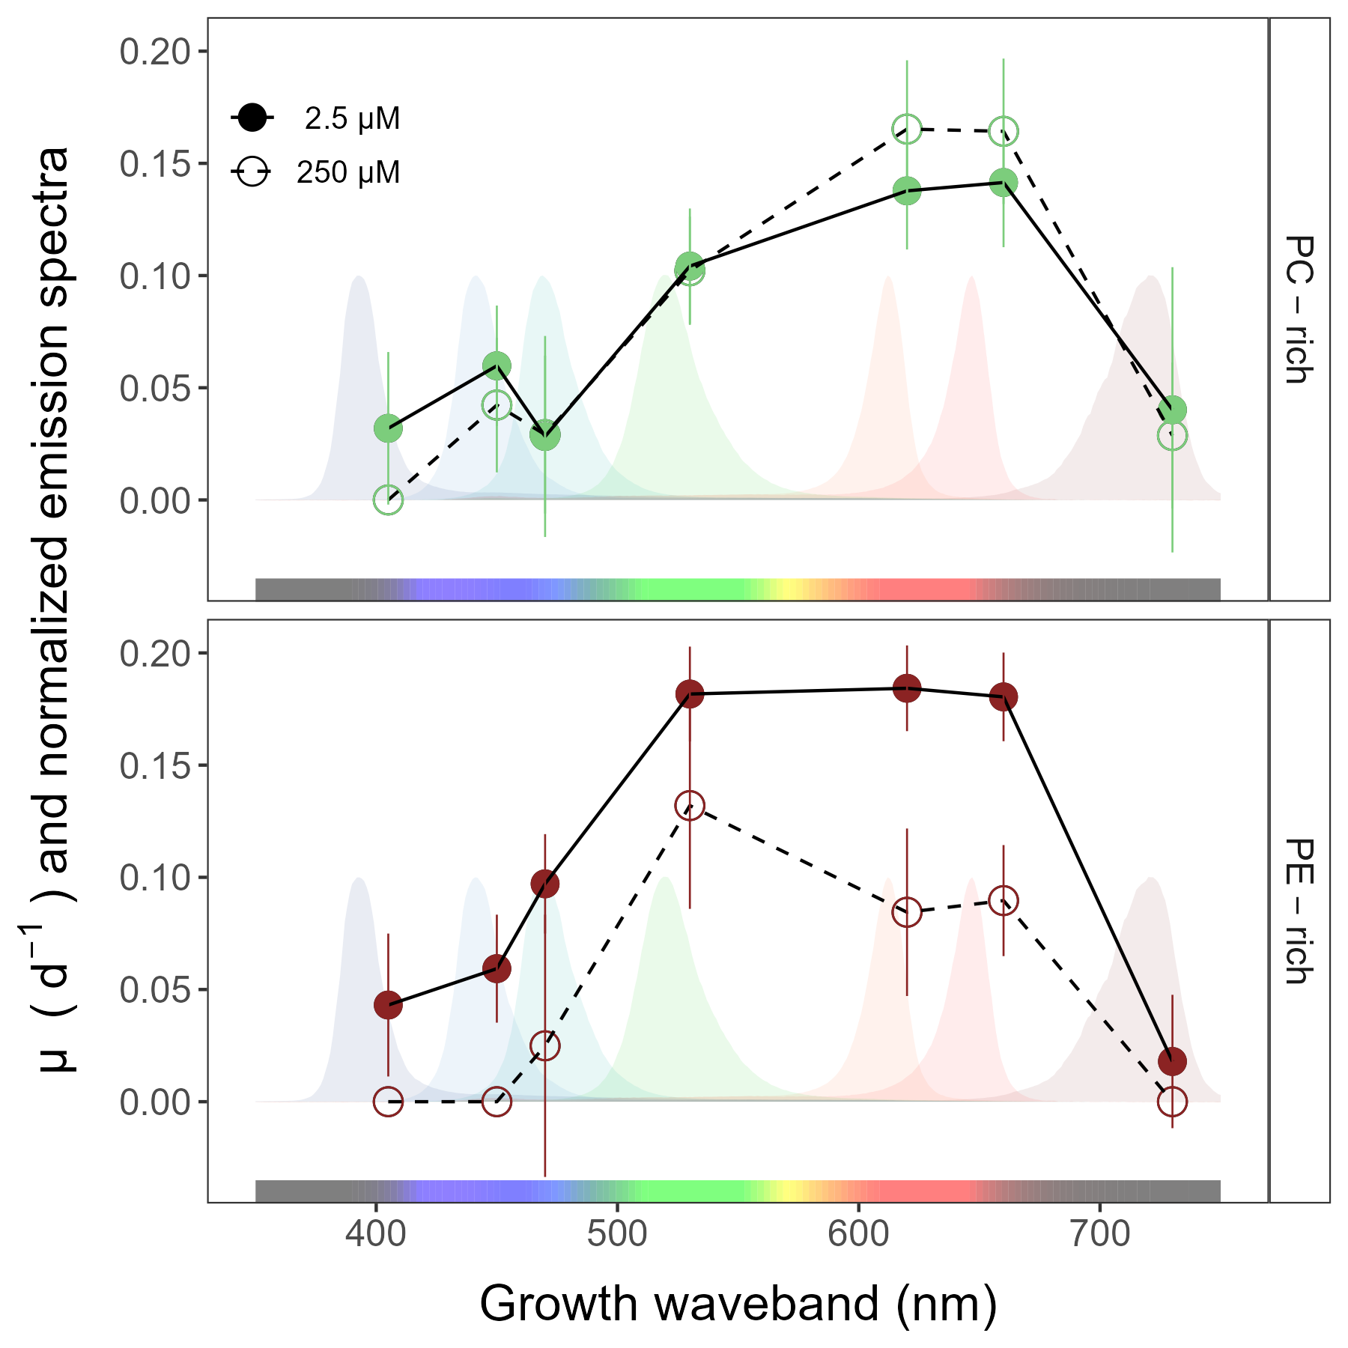

**Fig.** 1: Chlorophyll-specific growth rates (µ; d−1) vs. growth waveband (nm, shaded regions). Growth rates (± SE) were estimated from logistic fits of chlorophyll proxy OD680 – OD720 (ΔOD) vs. elapsed time (Fig. S1), for PC-rich (green circle) and PE-rich (red circle) cultures of *Synechococcus* grown at spectral wavebands of 405, 450, 470, 530, 620, 660, or 730 nm, and [O2] of 250 µM (open symbols and dashed line) or 2.5 µM (closed symbols and solid line).

## Pigment content and pigment ratio across [O2], spectral wavebands, and strains

Fig. 2*a* presents Chlorophyll *a* (Chl *a*), Phycobiliproteins (Phyco), or Carotenoids (Car) content (pg cell −1) vs. growth waveband (nm) for PC-rich and PE-rich cultures of *Synechococcus* grown at spectral wavebands centred at 405, 450, 470, 530, 620, 660, or 730 nm and 250 or 2.5 µM [O2]. We also calculated the Car to Chl *a* ratio, and the ratio of the sum of Phycobiliproteins to Chl *a* (µg:µg) for each strain (Fig. S3). Moreover, phycobiliproteins:Chlorophyll *a* ratio (µg:µg) and chlorophyll-specific growth rates (µ; d−1) vs. Photosynthetically Usable Radiation (PUR, µmol photons m−2s−1) for PC-rich and PE-rich cultures of *Synechococcus* grown at spectral wavebands of 405, 450, 470, 530, 620, 660, or 730 nm and 250 µM [O2] or 2.5 µM [O2] are presented in Fig. S4.

To focus on the responses of growing cells, we omit pigmentation data from those PE-rich cultures which showed negligible growth under 405, 450, 730 nm and 250 µM [O2]; and from those PC-rich cultures which showed negligible growth under 405 nm and 250 µM [O2].

Strain, growth waveband, [O2], and their interactions, significantly affected cell-specific Chl *a*, Phycobiliproteins, and Car content (Tab. S5). For the PC-rich strain, the highest Chl *a*, Phycobiliproteins, and Car contents were recorded after growth under 730 nm. The phycobiliproteins content was higher under 250 µM [O2] than under 2.5 µM [O2] for the PC-rich strain. In contrast, for PE-rich *Synechococcus*, phycobiliproteins content was significantly lower under 250 µM [O2] than under 2.5 µM [O2], with the highest phycobiliproteins content under 620 nm and 2.5 µM [O2].

Chlorophyll-specific growth rates (µ; d−1) show positive linear responses to the Phycobiliproteins:Chlorophyll *a* ratio (µg:µg), for both PC-rich and PE-rich *Synechococcus* (Fig. 2*b*), although the relations vary across strain and [O2] (Tab. S11).

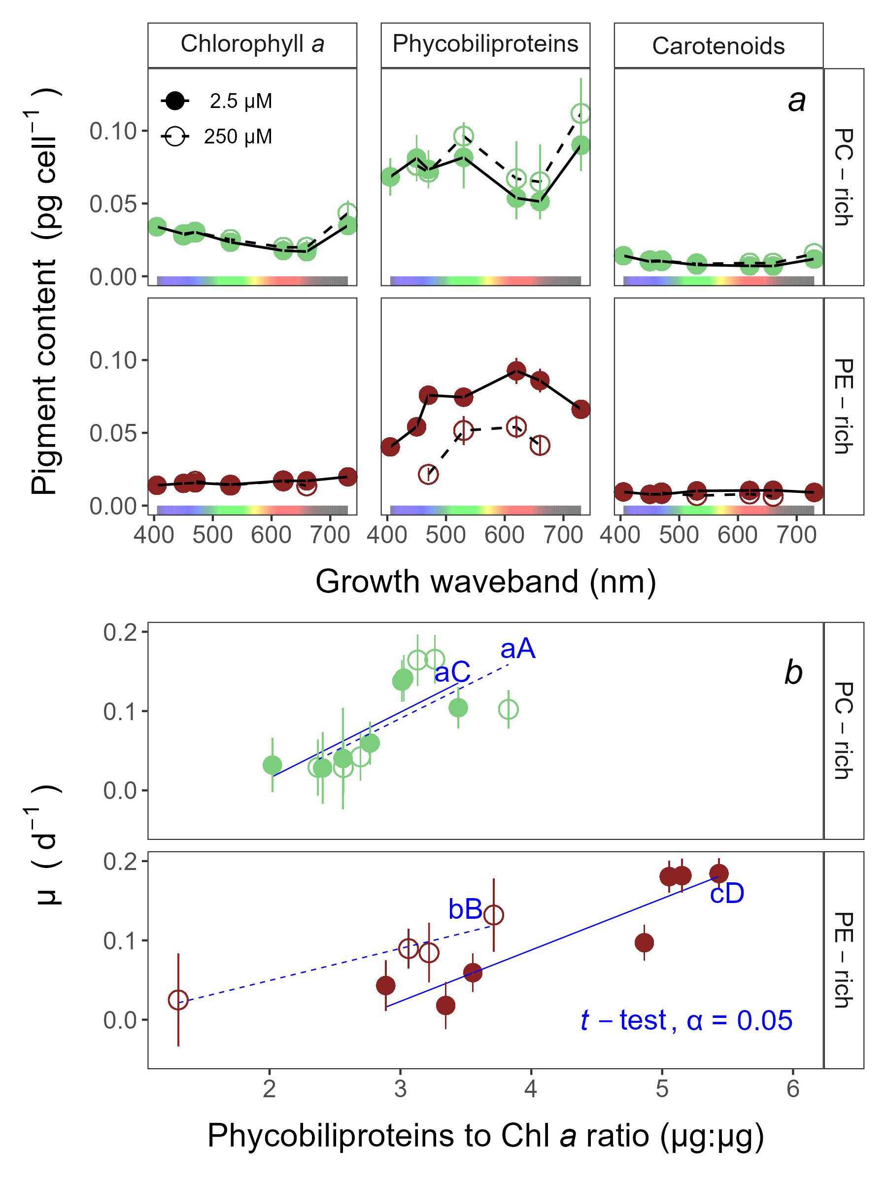

**Fig.** 2: Pigment content (pg cell −1) vs. growth waveband (nm) (*a*) and Chlorophyll-specific growth rates (µ; d−1) vs. Phycobiliproteins:Chlorophyll *a* ratio (µg:µg) (*b*) for PC-rich (green circle) and PE-rich (red circle) cultures of *Synechococcus* grown at spectral wavebands of 405, 450, 470, 530, 620, 660, or 730 nm and 250 µM [O2] (open symbols and dashed line) or 2.5 µM [O2] (closed symbols and solid line). Data not presented for those PE-rich cultures which showed negligible growth under 405, 450, 730 nm and 250 µM [O2]; nor for those PC-rich cultures which showed negligible growth under 405 nm and 250 µM [O2]. Blue lines shows linear model fit for data from each strain and [O2] (solid for 2.5 µM [O2] or dashed for 250 µM [O2]) across spectral wavebands. Different blue lowercase letters indicate statistically significant differences between the fit models for different [O2] within a given strain. Different blue uppercase letters indicate statistically significant differences between the fit models for different strains within a given [O2] (*t*-test; *p* < 0.05).

## Effective absorption cross sections, turnover times, and photochemical quenching of PSII across [O2], spectral wavebands, and strains

Light response curves of effective absorption cross section of PSII (σPSII; nm2 quanta−1); turnover time of PSII photochemistry (τPSII; µs); and the photochemical quenching coefficient (qP) vs. Actinic PAR (µmol photons m−2s−1) (Fig. 3*a-c*) are shown for PC-rich and PE-rich cultures grown in, and excited by, corresponding wavebands of 450, 470, 530, or 620 nm, at 250 µM or 2.5 µM [O2]. We omit functional data determined for those PE-rich cultures which showed negligible growth under 405, 450, 730 nm and 250 µM O2; and for those PC-rich cultures which showed negligible growth under 405 nm and 250 µM O2. In the Supplementary materials (Fig S5-S7), we also show the light response curves for all available excitation (Ex445nm, blue; Ex470nm, blue-green; Ex535nm, green; or Ex590nm, orange) and growth waveband (450, 470, 530, or 620 nm) cross-combinations.

σPSII (Fig. 3*a*), a measure of excitation driving PSII photochemistry, was low and shows little change with increasing actinic light during excitation through chlorophyll at Ex445nm. For the PC-rich strain, under orange excitation at Ex590nm, σPSII showed an initial small increase from darkness to the growth light level, followed by a mild decrease with increasing Actinic PAR, and was higher at 250 µM [O2] compared to 2.5 µM [O2]. For the PE-rich strain, we again see a small increase from darkness to the growth light level, followed by a decrease in σPSII with increasing Actinic PAR. Moreover, for the PE-rich strain σPSII was higher in low [O2] conditions than in high [O2] conditions. Strain, Actinic PAR, and [O2] significantly influenced σPSII under excitation at Ex590nm (Tab. S6).

For the PC-rich strain, across the excitation wavebands tested, τPSII showed an acceleration (decrease) from darkness to growth light Actinic PAR (Fig. 3*b*), to a plateau of ~ 800 µs. PE-rich strains, on the other hand, showed a progressive acceleration (decrease) with increasing Actinic PAR under excitation at Ex470nm, Ex535nm, or Ex590nm, declining towards ~ 400 µs under Ex590nm. Thus, the PE-rich strain showed more capacity to remove electrons from PSII. τPSII, was generally faster (smaller) for both PC-rich and PE-rich strains under 250 µM [O2]. Strain, Actinic PAR, and [O2] significantly affected τPSII at Ex470nm, Ex535nm and Ex590nm (Tab. S7).

qP, a measure of the fraction of PSII available for photochemistry, showed a strong decrease with increasing Actinic PAR across the excitation wavebands tested (Fig. 3*c*). qP generally remained higher for both PC-rich and PE-rich strains under 250 µM [O2]. Strain, Actinic PAR, and [O2] significantly affected qP at Ex470nm, Ex535nm, and Ex590nm (Tab. S8).

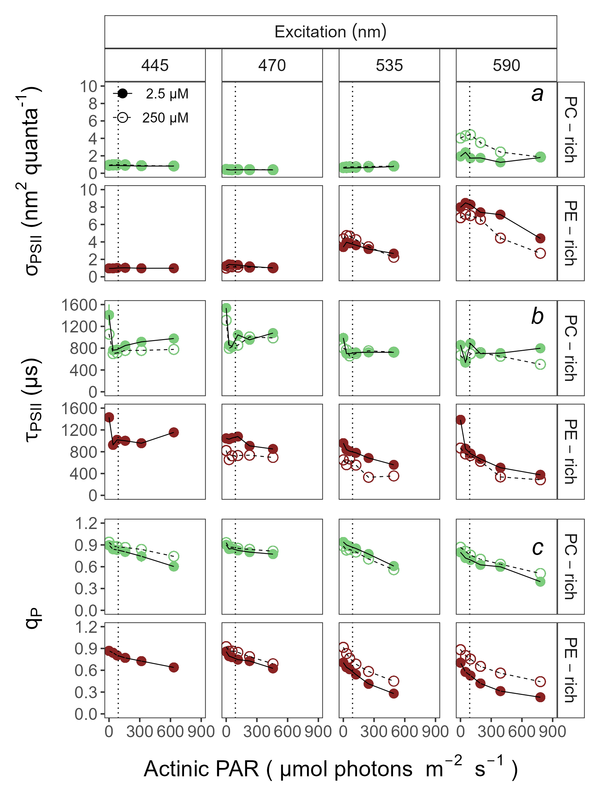

**Fig.** 3: Effective absorption cross section of PSII (σPSII; nm2 quanta−1) (*a*); turnover time of PSII photochemistry (τPSII; µs) (*b*); or photochemical quenching coefficient (qP) (*c*) vs. Actinic PAR (µmol photons m−2s−1). Parameters were estimated using FRRf induction curves with excitation (columns) at Ex445nm, blue; Ex470nm, blue-green; Ex535nm, green; or Ex590nm, orange; for PC-rich (green circle) or PE-rich (red circle) cultures of *Synechococcus*. Data show situations in which cultures were excited by, and growing in, corresponding growth wavebands of 450, 470, 530, or 620 nm and 250 µM [O2] (open symbols and dashed line) or 2.5 µM [O2] (closed symbols and solid line). The vertical lines show half diel peak PAR growth light of 90 µmol photons m−2s−1. Data not presented for those PE-rich cultures which showed negligible growth under 405, 450, 730 nm and 250 µM O2; nor for those PC-rich cultures which showed negligible growth under 405 nm and 250 µM O2.

## PSII electron flux across [O2], spectral wavebands, and strains

PSII electron flux (*JV*PSII) measures the generation of reductant available to support biosynthetic assimilation and growth. *JV*PSII was estimated using FRRf inductions with excitation at Ex445nm, Ex470nm, Ex535nm, or Ex590nm, corresponding to growth wavebands of 450, 470, 530, or 620 nm and 250 µM or 2.5 µM [O2]. To focus on responses of growing cells, we do not present *JV*PSII data for those PE-rich cultures which showed negligible growth under 405, 450, 730 nm and 250 µM O2; nor for those PC-rich cultures which showed negligible growth under 405 nm and 250 µM O2. PSII electron flux (*JV*PSII; µmol e− µmol Chl *a*−1 s−1) vs. Actinic PAR (µmol photons m−2s−1) estimated using FRRf induction curves with excitation at Ex445nm, blue; Ex470nm, blue-green; Ex535nm, green; or Ex590nm, orange; for PC-rich or PE-rich cultures of *Synechococcus* grown at spectral bandwidths of 450, 470, 530, or 620 nm and O2 concentrations of 250 µM or 2.5 µM are also presented (Fig. S8).

Light response curves of PSII electron flux (*JV*PSII; µmol e− µmol Chl *a*−1 s−1) vs. Actinic PAR (µmol photons m−2s−1) are shown in Fig. 4*a*. For the PC-rich strain, under all tested excitations (Ex445nm, Ex470nm, Ex535nm, or Ex590nm), *JV*PSII increased with increasing Actinic PAR, and did not fully saturate across the range of tested actinic PAR. Under all excitations, except Ex590nm, *JV*PSII was higher at 2.5 µM [O2] compared to 250 µM [O2] for the PC-rich strain. Conversely, for the PE-rich strain, *JV*PSII under Ex470nm, Ex535nm, or Ex590nm was higher at 250 µM [O2] compared to 2.5 µM [O2]. Moreover, for the PE-rich strain, *JV*PSII plateaued above ~90 µmol photons m−2s−1 under Ex535nm, or Ex590nm for both low and high [O2]. Strain, Actinic PAR, and [O2] significantly influence *JV*PSII under some of the tested excitations (Tab. S9), but *JV*PSII for cultures grown under, and excited through, Ex445nm, absorbed by chlorophyll, shows no difference between low and high [O2] with increasing actinic light.

Fig. 4*b* presents linear regressions between chlorophyll-specific growth rates (µ; d−1) and cumulative diel PSII electron flux (*JV*PSII; µmol e− µmol Chl *a*−1 d−1) measured under half (90 µmol photons m−2s−1) of the diel peak PAR growth light. µ (d−1), as expected, was positively correlated with *JV*PSII, with slopes significantly greater than 0. [O2] significantly influences the linear regressions between chlorophyll-specific growth rates and PSII electron flux for both PC-rich and PE-rich strains of *Synechococcus* (*p* < 0.05, Tab. S12). In the PC-rich strain higher [O2] increases the growth yield of electron transport. In contrast, the PE-rich strain, under higher [O2], decreases the growth yield of electron transport. However, the regressions for a given [O2] are not significantly different between the two strains (*p* > 0.05, Tab. S12).

Strain, actinic PAR waveband, and [O2] significantly influence Strain, Actinic PAR, and [O2] significantly influence our metric of Chl *a* : PSII (?? (Tab. S9), with Chl *a* : PSII higher under 250 than under 2.5 µM [O2] in the PC-rich strain, and Chl *a* : PSII generally lower in the PC-rich stain compared to the PE-rich strain.

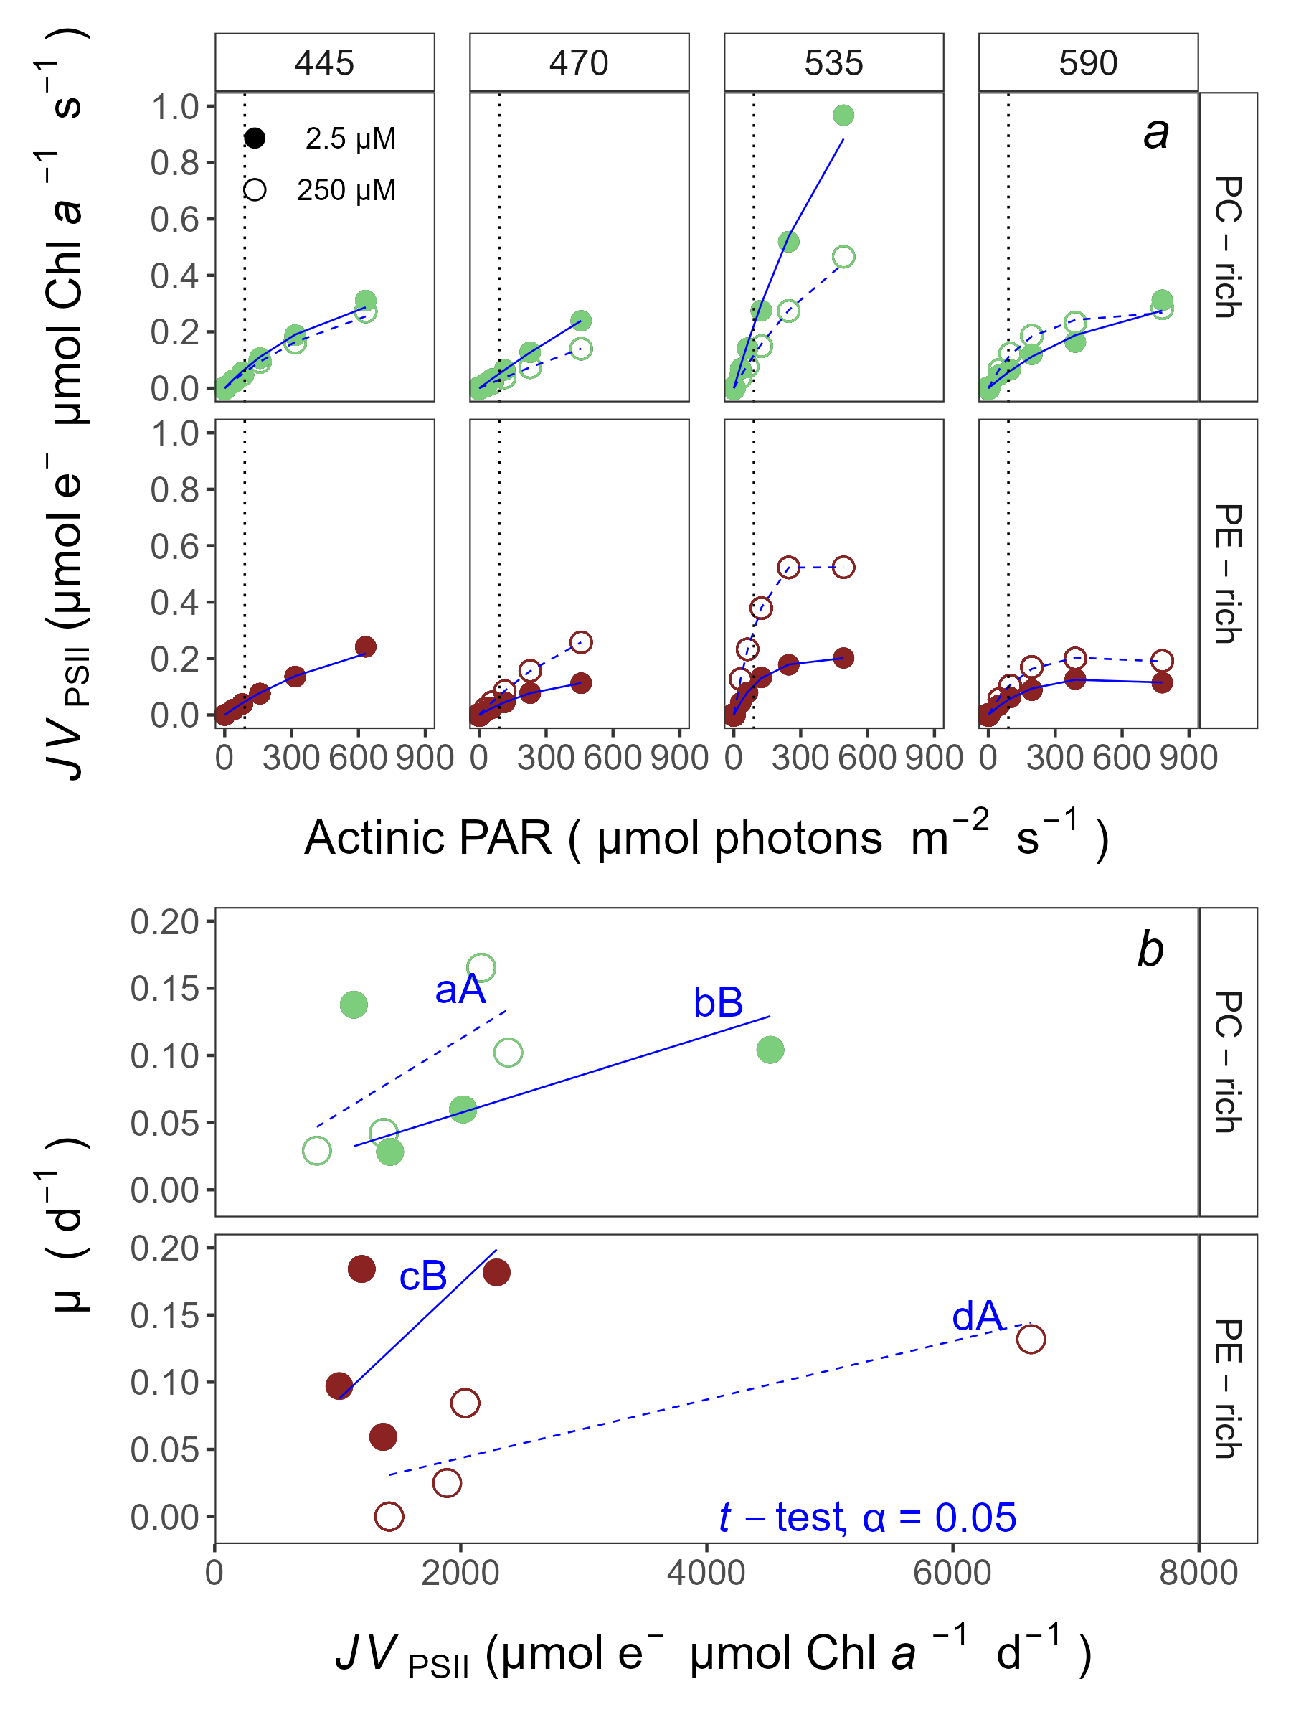

**Fig.** 4: PSII electron flux (*JV*PSII; µmol e− µmol Chl *a*−1 s−1) vs. Actinic PAR (µmol photons m−2s−1) (*a*). *JV*PSII was estimated using FRRf induction curves with excitation at Ex445nm, blue; Ex470nm, blue-green; Ex535nm, green; or Ex590nm, orange; for PC-rich (green circle) or PE-rich (red circle) cultures of *Synechococcus*. Data show situations in which cultures were excited by, and growing in, corresponding growth wavebands of 450, 470, 530, or 620 nm and 250 µM [O2] (open symbols and dashed line) or 2.5 µM [O2] (closed symbols and solid line). *JV*PSII vs. Actinic PAR (µmol photons m−2s−1) was fit with a Harrison and Platt Light Response Curve model (Harrison and Platt 1986), used to estimated *JV*PSII at 90 µmol photons m−2s−1 (vertical dotted lines). Chlorophyll-specific growth rates (µ; d−1) vs. PSII electron flux (*JV*PSII; µmol e− µmol Chl *a*−1 d−1) measured under half (90 µmol photons m−2s−1) of diel peak PAR growth light (*b*). Blue lines (solid for 2.5 µM [O2] or dashed for 250 µM O2) show linear model fit for data from each strain across spectral wavebands. Different blue lowercase letters indicate statistically significant differences between the fit models for different [O2] within a given strain. Different blue uppercase letters indicate statistically significant differences between the fit models for different strains within a given [O2] (*t*-test; *p* < 0.05).

# Discussion

## Growth responses of PC-rich and PE-rich picocyanobacteria across [O2] and spectral wavebands

Picocyanobacteria from the genus *Synechococcus* are major contributors to primary marine production, across a wide range of environments (Śliwińska-Wilczewska et al. 2018a; Aguilera et al. 2023) but interactive influences of [O2] and spectral wavebands on their growth rates and ecophysiology have not yet been investigated.

PC-rich and PE-rich *Synechococcus* from coastal habitats are exposed to changes in irradiance, spectral waveband, and sometimes [O2], by vertical movements through the mixed layer. Fluctuation in spectral wavebands changes the balance between productive photosynthesis, and photoinactivation of PSII (Six et al. 2007), increasing the cost of growth by diverting protein metabolism towards PSII repair (Murphy et al. 2017). Indeed, under 250 µM [O2], the PC-rich strain failed to grow under 405 nm, while the PE-rich strain failed to grow under 405 and 450, consistent with accelerated photoinactivation of PSII under blue wavebands (Murphy et al. 2017). In contrast, growth persisted in both strains at 405 & 450 nm under 2.5 µM [O2], likely because generation of toxic Reactive Oxygen Species (ROS) was suppressed, lowering the burden of photoinactivation of PSII.

µ shows positive responses to both Phycobiliproteins:Chlorophyll *a* ratio, an index of light capture capacity, and to cumulative diel PSII electron flux (*JV*PSII) for *Synechococcus*, although the relations varied across strain and with [O2]. In the PC-rich strain lower [O2] lowered the yield of growth per electron flux, while in the PE-rich strain the yield of growth per electron flux increased under lower [O2]. Note that these regressions excluded those conditions where no growth occurred. In contrast, growth showed no correlation to estimated Photosynthetically Usuable Radiation (PUR) (Fig. S4), likely because of variable allocations of excitation from phycobilisomes across growth conditions (Campbell 1996), not captured in the PUR metric based upon light absorption.

Wong et al. (2023) found that vertical structures of phytoplankton communities in OMZ are not sufficiently explained by top-down predation pressure nor light and/or nutrient limitation and thus, some phytoplankton may have a higher than expected direct O2 requirement, with growth inhibited by low O2 levels. However, in our work we show that low oxygen levels either do not affect, or sometimes even benefit, growth of different *Synechococcus* phenotypes across spectral wavebands. What is more, historical data link major extinction events to warm climates and oxygen-deficient oceans, with current anthropogenic activities possibly leading to widespread OMZ within a thousand years (Breitburg et al. 2018). The PC-rich *Synechococcus* strain showed generally similar growth rates under high and low tested [O2], while the PE-rich strain achieved faster growth rates under low (2.5 µM) than under high (250 µM) [O2]. PE-rich *Synechococcus* are typically found at greater depths, and lower light, than are PC-rich strains (Haverkamp et al. 2009; Śliwińska-Wilczewska et al. 2018a) but we suggest that the PE-rich strains may actually be limited to lower light niches by the interaction between light level, spectral band, and full air-saturated [O2]. In lower oxygen waters PE-rich strains will likely exploit higher light niches nearer the surface.

## Physiological adaptations of PC-rich and PE-rich picocyanobacteria to [O2] and spectral wavebands

*Synechococcus* strains vary widely in pigment composition, enabling them to exploit different spectral niches (Moore et al. 1995; Six et al. 2007; Grébert et al. 2018; Efimova et al. 2020). With a small diameter of 0.8–2.0 µm, *Synechococcus* possess a high surface-to-volume ratio (Śliwińska-Wilczewska et al. 2018b), minimizing pigment package effects (Finkel 2001), and resulting in high optical absorption per pigment. This characteristic allows them to thrive under low light deep in the water column (Moore et al. 1995), and to disproportionately influence sub-surface light fields (Berthold and Schumann 2020). Although limited package effect increases photon capture per pigment investment, it also increases *Synechococcus* susceptibility to light-induced damage (Llabrés and Agustí 2006, 2010). In some *Synechococcus*, a carotenoid-protein complex regulates the connectivity of the phycobilisome to the reaction center, mediating a form of non-photochemical quenching of excitation (Wilson et al. 2006; Gorbunov et al. 2011; Kirilovsky 2015). In our work we found no change in bulk carotenoids content (Fig. 2), nor in Car to Chl *a* ratio (Fig. S3) under the different [O2]. What is more, for the PE-rich strain, the carotenoids content did not change across tested wavebands. On the other hand, for PC-rich picocyanobacteria, a slight increase in carotenoids content was recorded under 405 nm, although these cells were not growing and were thus under stress.

σPSII was low and showed little change with increasing actinic light during excitation through chlorophyll at Ex445nm, because in cyanobacteria the number of chlorophyll per PSII is low, and nearly fixed, so the effective absorption cross section of PSII for chlorophyll is low (Xu et al. 2018). With excitation through the phycobilisomes at 535 and 590 nm σPSII rose to a peak near the acclimated light level of ~ 90 µmol photons m−2s−1 (Campbell and Oquist 1996), reflecting the state transition mechanism.

τPSII was generally faster for both PC-rich and PE-rich strains under 250 µM [O2], consistent with the cyanobacterial capacity for pseudo-cyclic electron flows away from PSII to [O2] (Campbell et al. 1999; Grossman et al. 2010; Allahverdiyeva et al. 2015; Hughes et al. 2018), thereby controlling feedback inhibition of electron transport, and decreasing the risks of ROS production. In parallel,qP was generally higher for PC-rich, and particularly for PE-rich strains, under 250 µM [O2], since cyanobacteria show strong capacity for electron flow away from PSII to O2 (Campbell et al. 1999; Hughes et al. 2018), particularly under excess excitation above the acclimated PAR of ~ 90 µmol photons m−2s−1. In spite of this superior electron transport performance under 250 µM [O2] the PE-rich strain grew faster under 2.5 µM [O2], showing an increase in the growth return upon electron transport.

Picocyanobacteria numerically dominate vast tracts of the oceans, contributing significant primary production, particularly in oligotrophic regions, but also some coastal habitats (Haverkamp 2008; Larsson et al. 2014; Doré et al. 2022; Aguilera et al. 2023). The ecological success of picoplanktonic *Synechococcus* reflects specific lineages occupying different niches to populate the world’s oceans (Scanlan 2012). Picocyanobacteria species can share the light spectrum by specializing in different wavelengths (Stomp et al. 2004, 2007; Haverkamp et al. 2009). Competition models and laboratory experiments show that PE-rich picocyanobacteria outperform competitors in green light while PC-rich picocyanobacteria dominate in red light, while both species can coexist across the full spectrum (Stomp et al. 2004, 2007). We now find that spectral wavebands interact with [O2] as determinants of growth rates across different *Synechococcus* strains, and that changing ocean [O2] may drive different pigmentation phenotypes into changing ecological niches.

# Acknowledgements

We thank Naaman M. Omar for assistance with coding, data analyses and culture maintenance; Miranda Corkum who maintained cultures and trained personnel in culture handling; Laurel Genge, and Carlie Barnhill (Mount Allison students) who assisted with R code.

# Article information

## Data availability statement

Data supporting this study is available on: <https://github.com/FundyPhytoPhys/BalticO2> (public GitHub Repository) and <https://docs.google.com/spreadsheets/d/1ZXpwR7Gfto-uRzVdXzMpQF4frbrvMLH_IyLqonFZRSw/edit#gid=0> (URL for MetaDataCatalog).

Code to perform data processing and analyses is available at <https://github.com/FundyPhytoPhys/BalticO2>.

# Author information

## Author ORCIDs

Sylwia Śliwińska-Wilczewska <https://orcid.org/0000-0002-3147-6605> Mireille Savoie <https://orcid.org/0009-0009-9499-6657> Douglas A. Campbell <https://orcid.org/0000-0001-8996-5463>

## Author contributions

Conceptualization: SSW, DAC Data curation: SSW Formal analysis: SSW, MS, DAC Funding acquisition: DAC Investigation: SSW Methodology: SSW, MS, DAC Project administration: DAC Resources: DAC Supervision: DAC Validation: SSW, MS, DAC Visualization: SSW Writing – original draft: SSW, MS, DAC

## Competing interests

The authors declare there are no competing interests.

## Funding information

This work was supported by Canada Research Chair in Phytoplankton Ecophysiology (DAC) and Latitude & Light; NSERC of Canada Discovery Grant (DAC).

# Supplementary material

Supplementary data are available with the article at https: //github.com/FundyPhytoPhys/BalticO2.

# References

Aguilera, A., Alegria Zufia, J., Bas Conn, L., Gurlit, L., Śliwińska-Wilczewska, S., Budzałek, G., Lundin, D., Pinhassi, J., Legrand, C., and Farnelid, H. 2023. Ecophysiological analysis reveals distinct environmental preferences in closely related Baltic Sea picocyanobacteria. Environmental Microbiology **25**(9): 1674–1695. doi:[10.1111/1462-2920.16384](https://doi.org/10.1111/1462-2920.16384).

Allahverdiyeva, Y., Isojärvi, J., Zhang, P., and Aro, E.-M. 2015. Cyanobacterial Oxygenic Photosynthesis is Protected by Flavodiiron Proteins. Life **5**(1): 716–743. Multidisciplinary Digital Publishing Institute. doi:[10.3390/life5010716](https://doi.org/10.3390/life5010716).

Andersson, B., Salter, A.H., Virgin, I., Vass, I., and Styring, S. 1992. Photodamage to photosystem II - primary and secondary events. Journal of Photochemistry and Photobiology B: Biology **15**(1): 15–31. doi:[10.1016/1011-1344(92)87003-R](https://doi.org/10.1016/1011-1344(92)87003-R).

Bagby, S.C., and Chisholm, S.W. 2015. Response of Prochlorococcus to varying CO2:O2 ratios. The ISME Journal **9**(10): 2232–2245. doi:[10.1038/ismej.2015.36](https://doi.org/10.1038/ismej.2015.36).

Bennett, A., and Bogorad, L. 1973. Complementary Chromatic Adaptation in a filamentous blue-green alga. Journal of Cell Biology **58**(2): 419–435. doi:[10.1083/jcb.58.2.419](https://doi.org/10.1083/jcb.58.2.419).

Berthold, M., and Schumann, R. 2020. Phosphorus Dynamics in a Eutrophic Lagoon: Uptake and Utilization of Nutrient Pulses by Phytoplankton. Frontiers in Marine Science **7**. Frontiers. doi:[10.3389/fmars.2020.00281](https://doi.org/10.3389/fmars.2020.00281).

Blake, R., and Griff, M. 2012. In situ spectroscopy on intact *Leptospirillum* *Ferrooxidans* reveals that reduced cytochrome 579 is an obligatory intermediate in the aerobic iron respiratory chain. Frontiers in Microbiology **3**. [accessed 13 June 2023].

Boatman, T.G., Geider, R.J., and Oxborough, K. 2019. Improving the accuracy of Single Turnover Active Fluorometry (STAF) for the estimation of Phytoplankton Primary Productivity (PhytoPP). Frontiers in Marine Science **6**. Frontiers. doi:[10.3389/fmars.2019.00319](https://doi.org/10.3389/fmars.2019.00319).

Breitburg, D., Levin, L.A., Oschlies, A., Grégoire, M., Chavez, F.P., Conley, D.J., Garçon, V., Gilbert, D., Gutiérrez, D., Isensee, K., Jacinto, G.S., Limburg, K.E., Montes, I., Naqvi, S.W.A., Pitcher, G.C., Rabalais, N.N., Roman, M.R., Rose, K.A., Seibel, B.A., Telszewski, M., Yasuhara, M., and Zhang, J. 2018. Declining oxygen in the global ocean and coastal waters. Science **359**(6371): eaam7240. American Association for the Advancement of Science. doi:[10.1126/science.aam7240](https://doi.org/10.1126/science.aam7240).

Callieri, C., Cabello-Yeves, P.J., and Bertoni, F. 2022. The “Dark Side” of Picocyanobacteria: Life as We Do Not Know It (Yet). Microorganisms **10**(3): 546. Multidisciplinary Digital Publishing Institute. doi:[10.3390/microorganisms10030546](https://doi.org/10.3390/microorganisms10030546).

Campbell, D. 1996. Complementary chromatic adaptation alters photosynthetic strategies in the cyanobacterium Calothrix. Microbiology **142**(5): 1255–1263. Microbiology Society,. doi:[10.1099/13500872-142-5-1255](https://doi.org/10.1099/13500872-142-5-1255).

Campbell, D., Clarke, A.K., Gustafsson, P., and Öquist, G. 1999. Oxygen-dependent electron flow influences photosystem II function and psbA gene expression in the cyanobacterium Synechococcus sp. PCC 7942. Physiologia Plantarum **105**(4): 746–755. doi:[10.1034/j.1399-3054.1999.105420.x](https://doi.org/10.1034/j.1399-3054.1999.105420.x).

Campbell, D., and Oquist, G. 1996. Predicting Light Acclimation in Cyanobacteria from Nonphotochemical Quenching of Photosystem II Fluorescence, Which Reflects State Transitions in These Organisms. Plant Physiology **111**(4): 1293–1298. doi:[10.1104/pp.111.4.1293](https://doi.org/10.1104/pp.111.4.1293).

Doré, H., Leconte, J., Guyet, U., Breton, S., Farrant, G.K., Demory, D., Ratin, M., Hoebeke, M., Corre, E., Pitt, F.D., Ostrowski, M., Scanlan, D.J., Partensky, F., Six, C., and Garczarek, L. 2022. Global Phylogeography of Marine Synechococcus in Coastal Areas Reveals Strong Community Shifts. mSystems **7**(6): e00656–22. American Society for Microbiology. doi:[10.1128/msystems.00656-22](https://doi.org/10.1128/msystems.00656-22).

Efimova, T.V., Churilova, T.Ya., and Mukhanov, V.S. 2020. The Influence of Light of Different Spectral Qualities on the Photosynthetic Characteristics of C-Phycocyanine-Containing Cyanobacteria Synechococcus sp. WH5701. Russian Journal of Marine Biology **46**(2): 105–112. doi:[10.1134/S1063074020020042](https://doi.org/10.1134/S1063074020020042).

Elzhov, T.V., Mullen, K.M., Spiess, A.-N., and Bolker, B. 2023, September. Minpack.lm: R Interface to the Levenberg-Marquardt Nonlinear Least-Squares Algorithm Found in MINPACK, Plus Support for Bounds. [accessed 15 March 2024].

Falkowski, P.G., Katz, M.E., Knoll, A.H., Quigg, A., Raven, J.A., Schofield, O., and Taylor, F.J.R. 2004. The Evolution of Modern Eukaryotic Phytoplankton. Science **305**(5682): 354–360. American Association for the Advancement of Science. doi:[10.1126/science.1095964](https://doi.org/10.1126/science.1095964).

Falkowski, P., and Kolber, Z. 1993. Estimation of phytoplankton photosynthesis by active fluorescence. ICES Marine Science Symposium **197**: 92–103.

Finkel, Z.V. 2001. Light absorption and size scaling of light-limited metabolism in marine diatoms. Limnology and Oceanography **46**(1): 86–94. doi:[10.4319/lo.2001.46.1.0086](https://doi.org/10.4319/lo.2001.46.1.0086).

Flombaum, P., Gallegos, J.L., Gordillo, R.A., Rincón, J., Zabala, L.L., Jiao, N., Karl, D.M., Li, W.K.W., Lomas, M.W., Veneziano, D., Vera, C.S., Vrugt, J.A., and Martiny, A.C. 2013. Present and future global distributions of the marine Cyanobacteria *Prochlorococcus* and *Synechococcus*. Proceedings of the National Academy of Sciences **110**(24): 9824–9829. Proceedings of the National Academy of Sciences. doi:[10.1073/pnas.1307701110](https://doi.org/10.1073/pnas.1307701110).

Gorbunov, M.Y., Kuzminov, F.I., Fadeev, V.V., Kim, J.D., and Falkowski, P.G. 2011. A kinetic model of non-photochemical quenching in cyanobacteria. Biochimica et Biophysica Acta (BBA) - Bioenergetics **1807**(12): 1591–1599. doi:[10.1016/j.bbabio.2011.08.009](https://doi.org/10.1016/j.bbabio.2011.08.009).

Grébert, T., Doré, H., Partensky, F., Farrant, G.K., Boss, E.S., Picheral, M., Guidi, L., Pesant, S., Scanlan, D.J., Wincker, P., Acinas, S.G., Kehoe, D.M., and Garczarek, L. 2018. Light color acclimation is a key process in the global ocean distribution of Synechococcus cyanobacteria. Proceedings of the National Academy of Sciences **115**(9): E2010–E2019. Proceedings of the National Academy of Sciences. doi:[10.1073/pnas.1717069115](https://doi.org/10.1073/pnas.1717069115).

Grossman, A.R., Mackey, K.R.M., and Bailey, S. 2010. A Perspective on Photosynthesis in the Oligotrophic Oceans: Hypotheses Concerning Alternate Routes of Electron Flow1. Journal of Phycology **46**(4): 629–634. doi:[10.1111/j.1529-8817.2010.00852.x](https://doi.org/10.1111/j.1529-8817.2010.00852.x).

Guillard, R.R.L. 1975. Culture of phytoplankton for feeding marine invertebrates. *In* Culture of Marine Invertebrate Animals: Proceedings — 1st Conference on Culture of Marine Invertebrate Animals Greenport. *Edited by* W.L. Smith and M.H. Chanley. Springer US, Boston, MA. pp. 29–60. doi:[10.1007/978-1-4615-8714-9_3](https://doi.org/10.1007/978-1-4615-8714-9_3).

Hakala, M., Tuominen, I., Keränen, M., Tyystjärvi, T., and Tyystjärvi, E. 2005. Evidence for the role of the oxygen-evolving manganese complex in photoinhibition of Photosystem II. Biochimica et Biophysica Acta (BBA) - Bioenergetics **1706**(1): 68–80. doi:[10.1016/j.bbabio.2004.09.001](https://doi.org/10.1016/j.bbabio.2004.09.001).

Handel, A. 2020, October. Andreas Handel - Custom Word formatting using R Markdown. https://www.andreashandel.com/posts/2020-10-07-custom-word-format/. [accessed 13 June 2023].

Harrison, W.G., and Platt, T. 1986. Photosynthesis-irradiance relationships in polar and temperate phytoplankton populations. Polar biology **5**: 153–164. Springer. [accessed 15 March 2024].

Haverkamp, T.H.A. 2008. Shades of red and green : The colorful diversity and ecology of picocyanobacteria in the Baltic Sea. YersekeNetherlands Institute of Ecology (NIOO) - Royal Netherlands Academy of Arts and Sciences. [accessed 3 July 2024].

Haverkamp, T.H.A., Schouten, D., Doeleman, M., Wollenzien, U., Huisman, J., and Stal, L.J. 2009. Colorful microdiversity of Synechococcus strains (picocyanobacteria) isolated from the Baltic Sea. The ISME Journal **3**(4): 397–408. doi:[10.1038/ismej.2008.118](https://doi.org/10.1038/ismej.2008.118).

Hughes, D.J., Campbell, D.A., Doblin, M.A., Kromkamp, J.C., Lawrenz, E., Moore, C.M., Oxborough, K., Prášil, O., Ralph, P.J., Alvarez, M.F., and Suggett, D.J. 2018. Roadmaps and Detours: Active Chlorophyll-a Assessments of Primary Productivity Across Marine and Freshwater Systems. Environmental Science & Technology **52**(21): 12039–12054. American Chemical Society. doi:[10.1021/acs.est.8b03488](https://doi.org/10.1021/acs.est.8b03488).

Jávorfi, T., Erostyák, J., Gál, J., Buzády, A., Menczel, L., Garab, G., and Razi Naqvi, K. 2006. Quantitative spectrophotometry using integrating cavities. Journal of Photochemistry and Photobiology B: Biology **82**(2): 127–131. doi:[10.1016/j.jphotobiol.2005.10.002](https://doi.org/10.1016/j.jphotobiol.2005.10.002).

Keeling, R.F., Körtzinger, A., and Gruber, N. 2010. Ocean Deoxygenation in a Warming World. Annual Review of Marine Science **2**(Volume 2, 2010): 199–229. Annual Reviews. doi:[10.1146/annurev.marine.010908.163855](https://doi.org/10.1146/annurev.marine.010908.163855).

Kirilovsky, D. 2015. Modulating energy arriving at photochemical reaction centers: Orange carotenoid protein-related photoprotection and state transitions. Photosynthesis Research **126**(1): 3–17. doi:[10.1007/s11120-014-0031-7](https://doi.org/10.1007/s11120-014-0031-7).

Kolber, Z.S., Prášil, O., and Falkowski, P.G. 1998. Measurements of variable chlorophyll fluorescence using fast repetition rate techniques: Defining methodology and experimental protocols. Biochimica et Biophysica Acta (BBA) - Bioenergetics **1367**(1): 88–106. doi:[10.1016/S0005-2728(98)00135-2](https://doi.org/10.1016/S0005-2728(98)00135-2).

Larsson, J., Celepli, N., Ininbergs, K., Dupont, C.L., Yooseph, S., Bergman, B., and Ekman, M. 2014. Picocyanobacteria containing a novel pigment gene cluster dominate the brackish water Baltic Sea. The ISME Journal **8**(9): 1892–1903. doi:[10.1038/ismej.2014.35](https://doi.org/10.1038/ismej.2014.35).

Latala, A., Jodlowska, S., and Pniewski, F. 2006. Culture Collection of Baltic Algae (CCBA) and characteristic of some strains by factorial experiment approach. Archiv fur Hydrobiologie **122**: 137–154. [accessed 19 June 2024].

Llabrés, M., and Agustí, S. 2006. Picophytoplankton cell death induced by UV radiation: Evidence for oceanic Atlantic communities. Limnology and Oceanography **51**(1): 21–29. doi:[10.4319/lo.2006.51.1.0021](https://doi.org/10.4319/lo.2006.51.1.0021).

Llabrés, M., and Agustí, S. 2010. Effects of ultraviolet radiation on growth, cell death and the standing stock of Antarctic phytoplankton. Aquatic Microbial Ecology **59**(2): 151–160. doi:[10.3354/ame01392](https://doi.org/10.3354/ame01392).

Luimstra, V.M., Schuurmans, J.M., Verschoor, A.M., Hellingwerf, K.J., Huisman, J., and Matthijs, H.C.P. 2018. Blue light reduces photosynthetic efficiency of cyanobacteria through an imbalance between photosystems I and II. Photosynthesis Research **138**(2): 177–189. doi:[10.1007/s11120-018-0561-5](https://doi.org/10.1007/s11120-018-0561-5).

Moore, L.R., Goericke, R., and Chisholm, S.W. 1995. Comparative physiology of Synechococcus and Prochlorococcus: Influence of light and temperature on growth, pigments, fluorescence and absorptive properties. Marine Ecology Progress Series **116**(1/3): 259–275. Inter-Research Science Center. Available from <https://www.jstor.org/stable/44635011> [accessed 1 July 2024].

Morel, A. 1978. Available, usable, and stored radiant energy in relation to marine photosynthesis. Deep Sea Research **25**(8): 673–688. doi:[10.1016/0146-6291(78)90623-9](https://doi.org/10.1016/0146-6291(78)90623-9).

Murphy, C.D., Roodvoets, M.S., Austen, E.J., Dolan, A., Barnett, A., and Campbell, D.A. 2017. Photoinactivation of Photosystem II in Prochlorococcus and Synechococcus. PLOS ONE **12**(1): e0168991. Public Library of Science. doi:[10.1371/journal.pone.0168991](https://doi.org/10.1371/journal.pone.0168991).

Oxborough, K., and Baker, N.R. 1997. Resolving chlorophyll *a* fluorescence images of photosynthetic efficiency into photochemical and non-photochemical components – calculation of qP and Fv-/Fm-; without measuring Fo-; Photosynthesis Research **54**(2): 135–142. doi:[10.1023/A:1005936823310](https://doi.org/10.1023/A:1005936823310).

Oxborough, K., Moore, C.M., Suggett, D.J., Lawson, T., Chan, H.G., and Geider, R.J. 2012. Direct estimation of functional PSII reaction center concentration and PSII electron flux on a volume basis: A new approach to the analysis of Fast Repetition Rate fluorometry (FRRf) data. Limnology and Oceanography: Methods **10**(3): 142–154. doi:[10.4319/lom.2012.10.142](https://doi.org/10.4319/lom.2012.10.142).

Partensky, F., Mella-Flores, D., Six, C., Garczarek, L., Czjzek, M., Marie, D., Kotabová, E., Felcmanová, K., and Prášil, O. 2018. Comparison of photosynthetic performances of marine picocyanobacteria with different configurations of the oxygen-evolving complex. Photosynthesis Research **138**(1): 57–71. doi:[10.1007/s11120-018-0539-3](https://doi.org/10.1007/s11120-018-0539-3).

Pedersen, T.L. 2024, January. Patchwork: The Composer of Plots. [accessed 20 April 2024].

Posit team. 2022. RStudio: Integrated development environment for r. Posit Software, PBC, Boston, MA. Available from <http://www.posit.co/>.

R Core Team. 2023. R: A language and environment for statistical computing. R Foundation for Statistical Computing, Vienna, Austria. Available from <https://www.R-project.org/>.

Scanlan, D.J. 2012. Marine Picocyanobacteria. *In* Ecology of Cyanobacteria II: Their Diversity in Space and Time. *Edited by* B.A. Whitton. Springer Netherlands, Dordrecht. pp. 503–533. doi:[10.1007/978-94-007-3855-3_20](https://doi.org/10.1007/978-94-007-3855-3_20).

Six, C., Finkel, Z.V., Irwin, A.J., and Campbell, D.A. 2007. Light variability illuminates niche-partitioning among marine picocyanobacteria. PLOS ONE **2**(12): e1341. Public Library of Science. doi:[10.1371/journal.pone.0001341](https://doi.org/10.1371/journal.pone.0001341).

Śliwińska-Wilczewska, S., Cieszyńska, A., Maculewicz, J., and Latała, A. 2018a. Ecophysiological characteristics of red, green, and brown strains of the Baltic picocyanobacterium *Synechococcus* sp. – a laboratory study. Biogeosciences **15**(20): 6257–6276. Copernicus GmbH. doi:[10.5194/bg-15-6257-2018](https://doi.org/10.5194/bg-15-6257-2018).

Śliwińska-Wilczewska, S., Maculewicz, J., Barreiro Felpeto, A., and Latała, A. 2018b. Allelopathic and bloom-forming picocyanobacteria in a changing world. Toxins **10**(1): 48. Multidisciplinary Digital Publishing Institute. doi:[10.3390/toxins10010048](https://doi.org/10.3390/toxins10010048).

Stomp, M., Huisman, J., de Jongh, F., Veraart, A.J., Gerla, D., Rijkeboer, M., Ibelings, B.W., Wollenzien, U.I.A., and Stal, L.J. 2004. Adaptive divergence in pigment composition promotes phytoplankton biodiversity. Nature **432**(7013): 104–107. Nature Publishing Group. doi:[10.1038/nature03044](https://doi.org/10.1038/nature03044).

Stomp, M., Huisman, J., Vörös, L., Pick, F.R., Laamanen, M., Haverkamp, T., and Stal, L.J. 2007. Colourful coexistence of red and green picocyanobacteria in lakes and seas. Ecology Letters **10**(4): 290–298. doi:[10.1111/j.1461-0248.2007.01026.x](https://doi.org/10.1111/j.1461-0248.2007.01026.x).

Strickland, J.D., and Parsons, T.R. 1972. Practical Hand Book of Seawater Analysis. Fisheries Research Board of Canada **167 (2nd edition)**: 1–311. doi:<DOI: http://dx.doi.org/10.25607/OBP-1791>.

Tortell, P., and Suggett, D.J. 2021. A user guide for the application of Single Turnover active chlorophyll fluorescence for phytoplankton productivity measurements. Version 1. Report, Scientific Committee on Oceanic Research (SCOR) Working Group 156. doi:[10.25607/OBP-1084](https://doi.org/10.25607/OBP-1084).

Ulloa, O., Canfield, D.E., DeLong, E.F., Letelier, R.M., and Stewart, F.J. 2012. Microbial oceanography of anoxic oxygen minimum zones. Proceedings of the National Academy of Sciences **109**(40): 15996–16003. Proceedings of the National Academy of Sciences. doi:[10.1073/pnas.1205009109](https://doi.org/10.1073/pnas.1205009109).

Ulloa, O., Henríquez-Castillo, C., Ramírez-Flandes, S., Plominsky, A.M., Murillo, A.A., Morgan-Lang, C., Hallam, S.J., and Stepanauskas, R. 2021. The cyanobacterium Prochlorococcus has divergent light-harvesting antennae and may have evolved in a low-oxygen ocean. Proceedings of the National Academy of Sciences **118**(11): e2025638118. Proceedings of the National Academy of Sciences. doi:[10.1073/pnas.2025638118](https://doi.org/10.1073/pnas.2025638118).

Wickham, H. 2016. Data Analysis. *In* Ggplot2: Elegant Graphics for Data Analysis. *Edited by* H. Wickham. Springer International Publishing, Cham. pp. 189–201. doi:[10.1007/978-3-319-24277-4_9](https://doi.org/10.1007/978-3-319-24277-4_9).

Wilson, A., Ajlani, G., Verbavatz, J.-M., Vass, I., Kerfeld, C.A., and Kirilovsky, D. 2006. A Soluble Carotenoid Protein Involved in Phycobilisome-Related Energy Dissipation in Cyanobacteria. The Plant Cell **18**(4): 992–1007. doi:[10.1105/tpc.105.040121](https://doi.org/10.1105/tpc.105.040121).

Wlodkowic, D., Czerw, A., Karakiewicz, B., and Deptała, A. 2022. Recent progress in cytometric technologies and their applications in ecotoxicology and environmental risk assessment. Cytometry Part A **101**(3): 203–219. doi:[10.1002/cyto.a.24508](https://doi.org/10.1002/cyto.a.24508).

Wong, J.C.Y., Raven, J.A., Aldunate, M., Silva, S., Gaitán-Espitia, J.D., Vargas, C.A., Ulloa, O., and von Dassow, P. 2023. Do phytoplankton require oxygen to survive? A hypothesis and model synthesis from oxygen minimum zones. Limnology and Oceanography **68**(7): 1417–1437. doi:[10.1002/lno.12367](https://doi.org/10.1002/lno.12367).

Xu, K., Grant-Burt, J.L., Donaher, N., and Campbell, D.A. 2017. Connectivity among Photosystem II centers in phytoplankters: Patterns and responses. Biochimica et Biophysica Acta (BBA) - Bioenergetics **1858**(6): 459–474. doi:[10.1016/j.bbabio.2017.03.003](https://doi.org/10.1016/j.bbabio.2017.03.003).

Xu, K., Lavaud, J., Perkins, R., Austen, E., Bonnanfant, M., and Campbell, D.A. 2018. Phytoplankton $σ$ PSII and excitation dissipation; implications for estimates of primary productivity. Frontiers in Marine Science **5**. doi:[10.3389/fmars.2018.00281](https://doi.org/10.3389/fmars.2018.00281).